Sources: Guidelines to Reporting and Writing About People with Disabilities, produced by the Media Project, Research and Training Center on Independent Living, 4089 Dole, University of Kansas, Lawrence, KS66045; Ten Commandments of Etiquette for Communicating with People with Disabilities, National Center for Access Unlimited, 155 North Wacker Drive, Suite 315, Chicago, IL 60606; and Beyond the AP Stylebook: Language and Usage Guide for Reporters and Editors, The Advocado Press, Inc. 402 W. Washington St., Room E145 Indianapolis, IN 46204 Phone: (317)232-7770 Fax: (317)233-3712 GPCPD@gpcpd.org Web site: www.in.gov/gpcpd Print copies of this document are available in brochure format on request Also available in accessible formats.

Disability
Etiquette
A Guide to Interacting with People with Disabilities Indiana Governor’s Council for People with Disabilities Living in a Diverse Culture and the Independent Living Center of Eastern Indiana

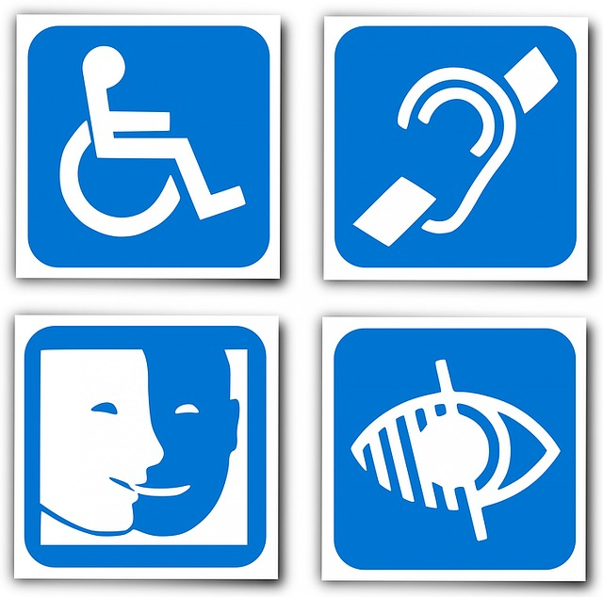

The Power of Words
The Council has designed this brochure to help enhance understanding and communication in everyday interactions with people with disabilities. Language – A Powerful Tool “Handicapped man confined to wheelchair...” “Girl stricken with cerebral palsy...” Words and phrases such as these shape incorrect perceptions of people with disabilities. Negative attitudes are often the greatest barrier for people with disabilities to overcome. Even the word “handicap” itself is considered insulting by many because it was a term coined by people outside the disability community. By working together to create positive attitudes toward people with disabilities, we can create a better society – and that is a positive step for everyone neighbors, friends, classmates, family members and co-workers. People with disabilities are people first. Yes, disabilities are part of their lives, but disabilities do not define people. Changes in laws, technology, public policies and attitudes have opened opportunities for people with disabilities to pursue education, recreation and employment in the mainstream of community life. Like other. People with disabilities are part of the landscape in a diverse America. The more than 54 million Americans with disabilities are Americans, people with disabilities live, work, attend school, play, worship and volunteer in their communities.

General Tid-bits

- Use large print on printed items (at least 16 point font).
- Use high contrast when possible.
- Do not print words on top of pictures.
- Have Gluten, Dairy, wheat free items clearly marked or separated.
- Have paper and pencil ready to assist in communicating to those with hearing loss.
- Make sure that your meeting/event space is accessible to all.
- Offer assistance and then WAIT for it to be accepted and explained how you can be helpful.
- Do not touch or address service animals, they are doing an important job (just like you).

Rules to use when writing or speaking about people with disabilities:
1. Always use people-first language. Refer to the person first and not his or her disability. Do not say “a disabled person.” Instead, refer to “a person with a disability.”
2. Never group individuals together as “the mentally retarded,” which puts the focus on the disability, not on the individual.
3. Avoid emotional and sensationalist words. People with disabilities are often either thought of as inspirational and courageous or pitiful and in need of charity. Both extremes are erroneous stereotypes. Be sensitive when choosing words. The reality is that people with disabilities succeed not “in spite of” their disabilities but “in spite of” an inaccessible and discriminatory society. They do not “overcome” their disabilities so much as “overcome” prejudice. You can help by using nonjudgmental terms and phrases that portray an image of dignity and respect.
4. Include a statement on the flyer regarding how to request an accommodation for your event. Such as “We are committed to making our events accessible to everyone. If you require an ADA accommodation or service to fully participate, please contact [NAME at EMAIL, PHONE NUMBER] at least {#} days prior to the event.”

Ten Tips of Etiquette
The following “Ten Commandments of Etiquette for Communicating with People with Disabilities” will help you communicate more
effectively with people with disabilities.
1. When talking with a person with a disability, use eye contact and speak directly to that person rather than through a companion or sign language interpreter.
2. When introduced to a person with a disability, it is appropriate to offer to shake hands. People with limited hand use or who wear an artificial limb usually can shake hands. (Shaking hands with the left hand is an acceptable greeting.)
3. When meeting a person who is visually impaired, always identify yourself and others who may be with you. When conversing in a group, remember to identify the person to whom you are speaking.
4. If you offer assistance, wait until the offer is accepted. Then listen to or ask for instructions.
5. Treat adults as adults. Address people who have disabilities by their first names only when extending the same familiarity to all others. Never patronize people who use wheelchairs by patting them on the head or shoulder.
6. A wheelchair is part of the personal body space of the person who uses it. Leaning on a person’s wheelchair is similar to leaning on a person and is generally considered inappropriate.
7. Listen attentively when you’re talking with a person who has difficulty speaking. Be patient and wait for the person to finish,
rather than correcting or speaking for the person. If necessary, ask short questions that require short answers, a nod or shake of the head. Never pretend to understand if you are having difficulty in doing so. Instead, repeat what you have understood and allow the person to respond.
8. When speaking with a person who uses a wheelchair or a person who uses crutches, place yourself at eye level in front of the person to facilitate the conversation.
9. To get the attention of a person who is deaf, tap the person on the shoulder or wave your hand. Look directly at the person and speak clearly, slowly and expressively to determine if the person can read your lips. Be sensitive to those who lip read by placing yourself so that you face the light source and keeping hands and food away from your mouth when speaking.
10. Relax. Don’t be embarrassed if you use common expressions – that seem to relate to a person’s disability. It’s okay to ask questions when you’re unsure of what to say. such as “See you later” or “Did you hear about that?”

Easy Ways to Avoid Inappropriate Language

DON’Ts DOs
Disrespectful terms Respectful terms
the disabled ……………………………….. disabled rights or group
crippled, spastic……………………..… cerebral palsy/paraplegia/ physical disability
retard, mongoloid……………………....… cognitive or intellectual impairment
dumb/deaf-mute……………………..…… communication disorder/ unable to speak/deaf
handicap………………………………..... disability
fit…………………………………………….... epilepsy/seizure
insane, crazy, deranged ……...…..…….. psychiatric disability
wheelchair bound/confined ………...…. uses a wheelchair
differently-abled ………………………….. avoid trendy or cute terms
stricken, victim or suffering from ….….… had or has a disability
patient ………………………………….….. use only if the person is under a doctor’s care
handicapped parking/seating…………. accessible parking/seating
special bus, special housing…………..… separate bus, segregated housing
the blind person with a disability…………..… people who are blind.

